1.Basic Calculator
Code:
student:-
write('Name:- Aswini'), nl,
write('Register Number:- 192312494'), nl.

add(A,B,C) :-
C is A+B.
subtract(A,B,C) :-
C is A-B.
multiply(A,B,C) :-
C is A*B.
divide(A,B,C) :-
C is A/B.

Output:
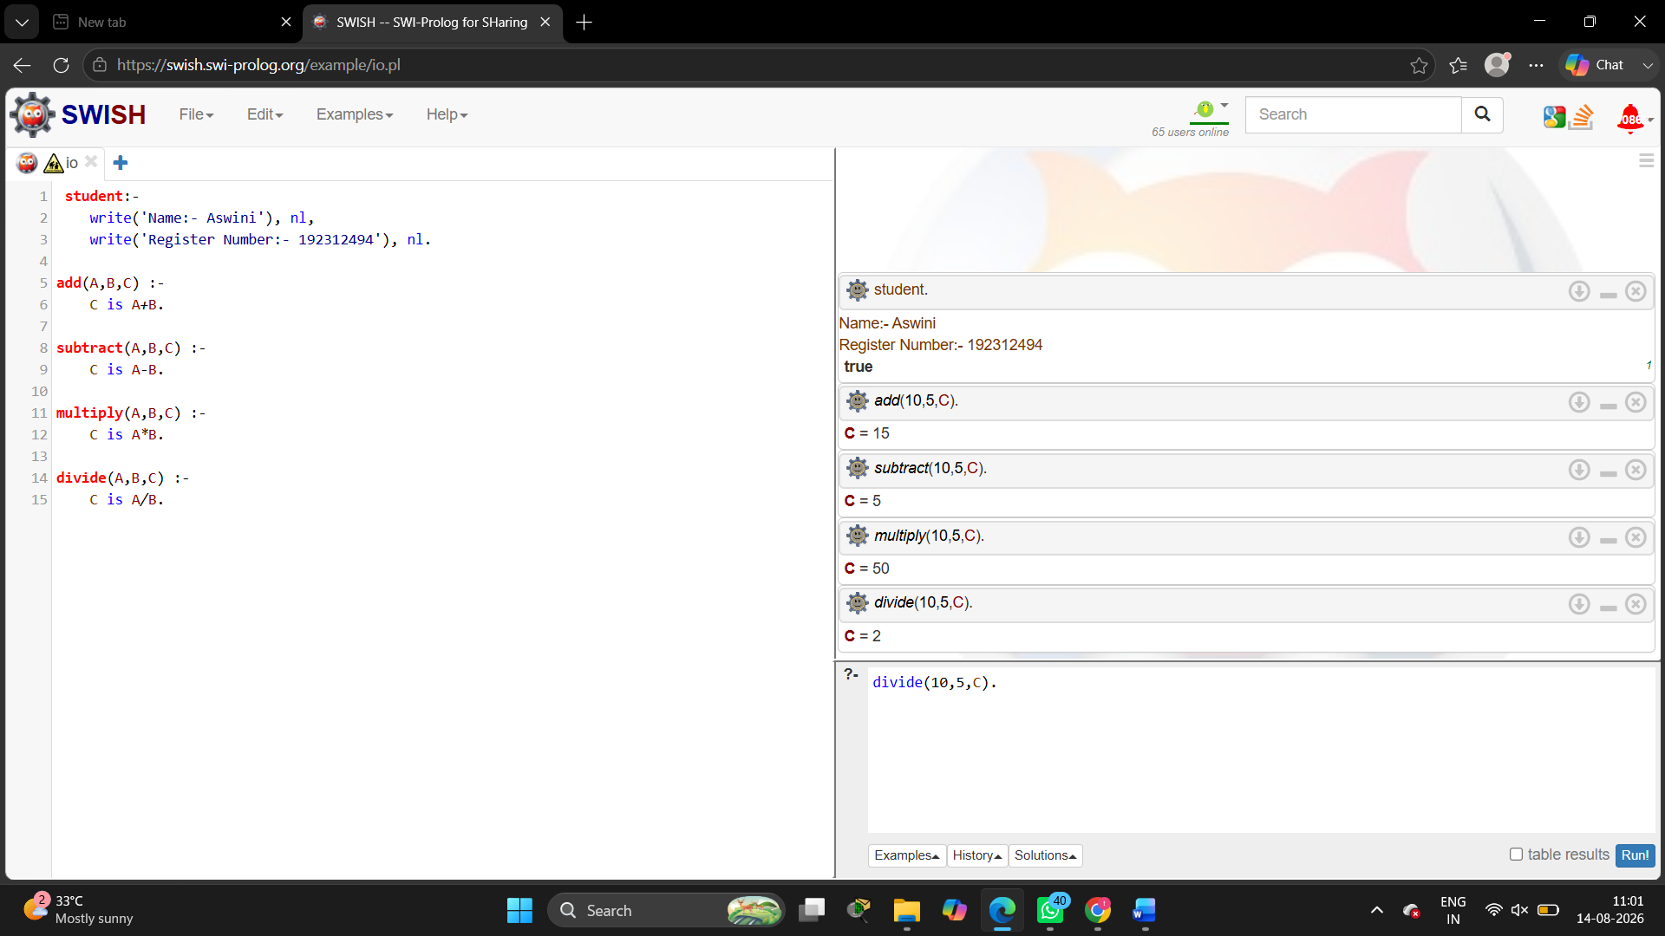
2.All Comparison
Code :
student:-
write('Name:- Aswini'), nl,
write('Register Number:- 192312494'), nl.
greater(A,B) :-
A > B.
less(A,B) :-
A < B.
greater_equal(A,B) :-
A >= B.
less_equal(A,B) :-
A =< B.
equal(A,B) :-
A =:= B.
not_equal(A,B) :-
A =\= B.
Output:
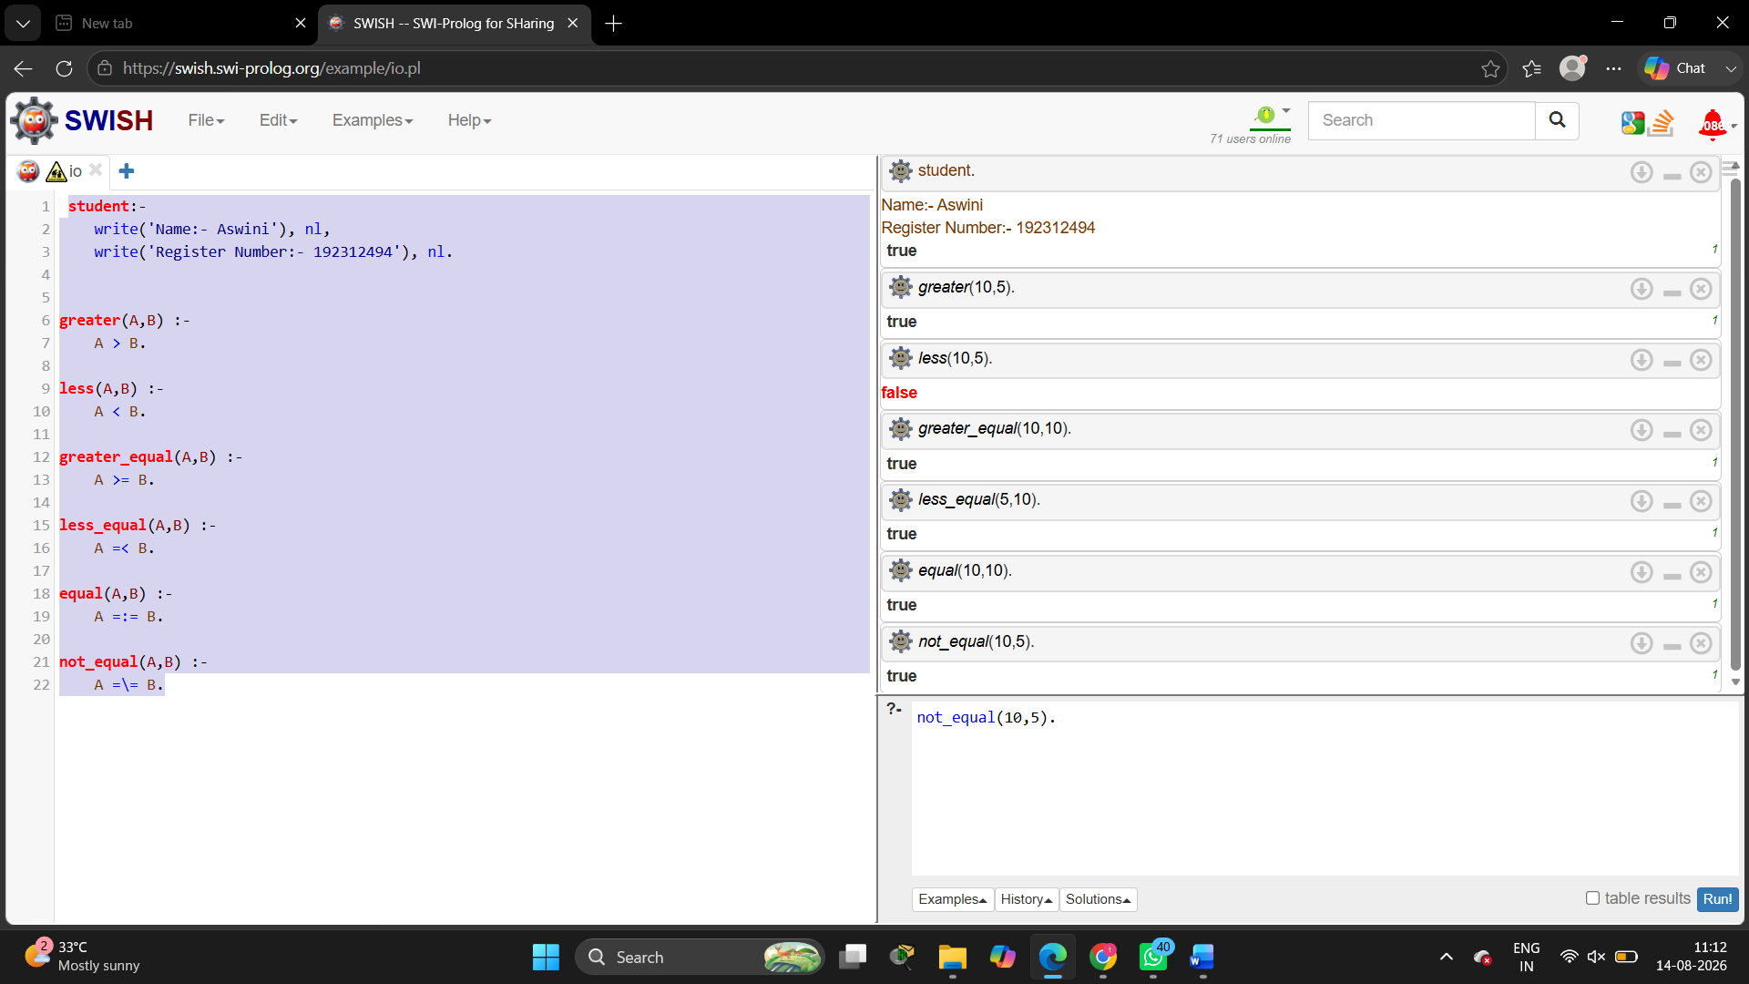
3.Vote eligibility
Code:
vote :-
write('Name:- Aswini'), nl,
write('Register Number:- 192312494'), nl.

eligible(Age) :-
Age >= 18,
write('Eligible for voting').

not_eligible(Age) :-
Age < 18,
write('Not eligible for voting').

Output:
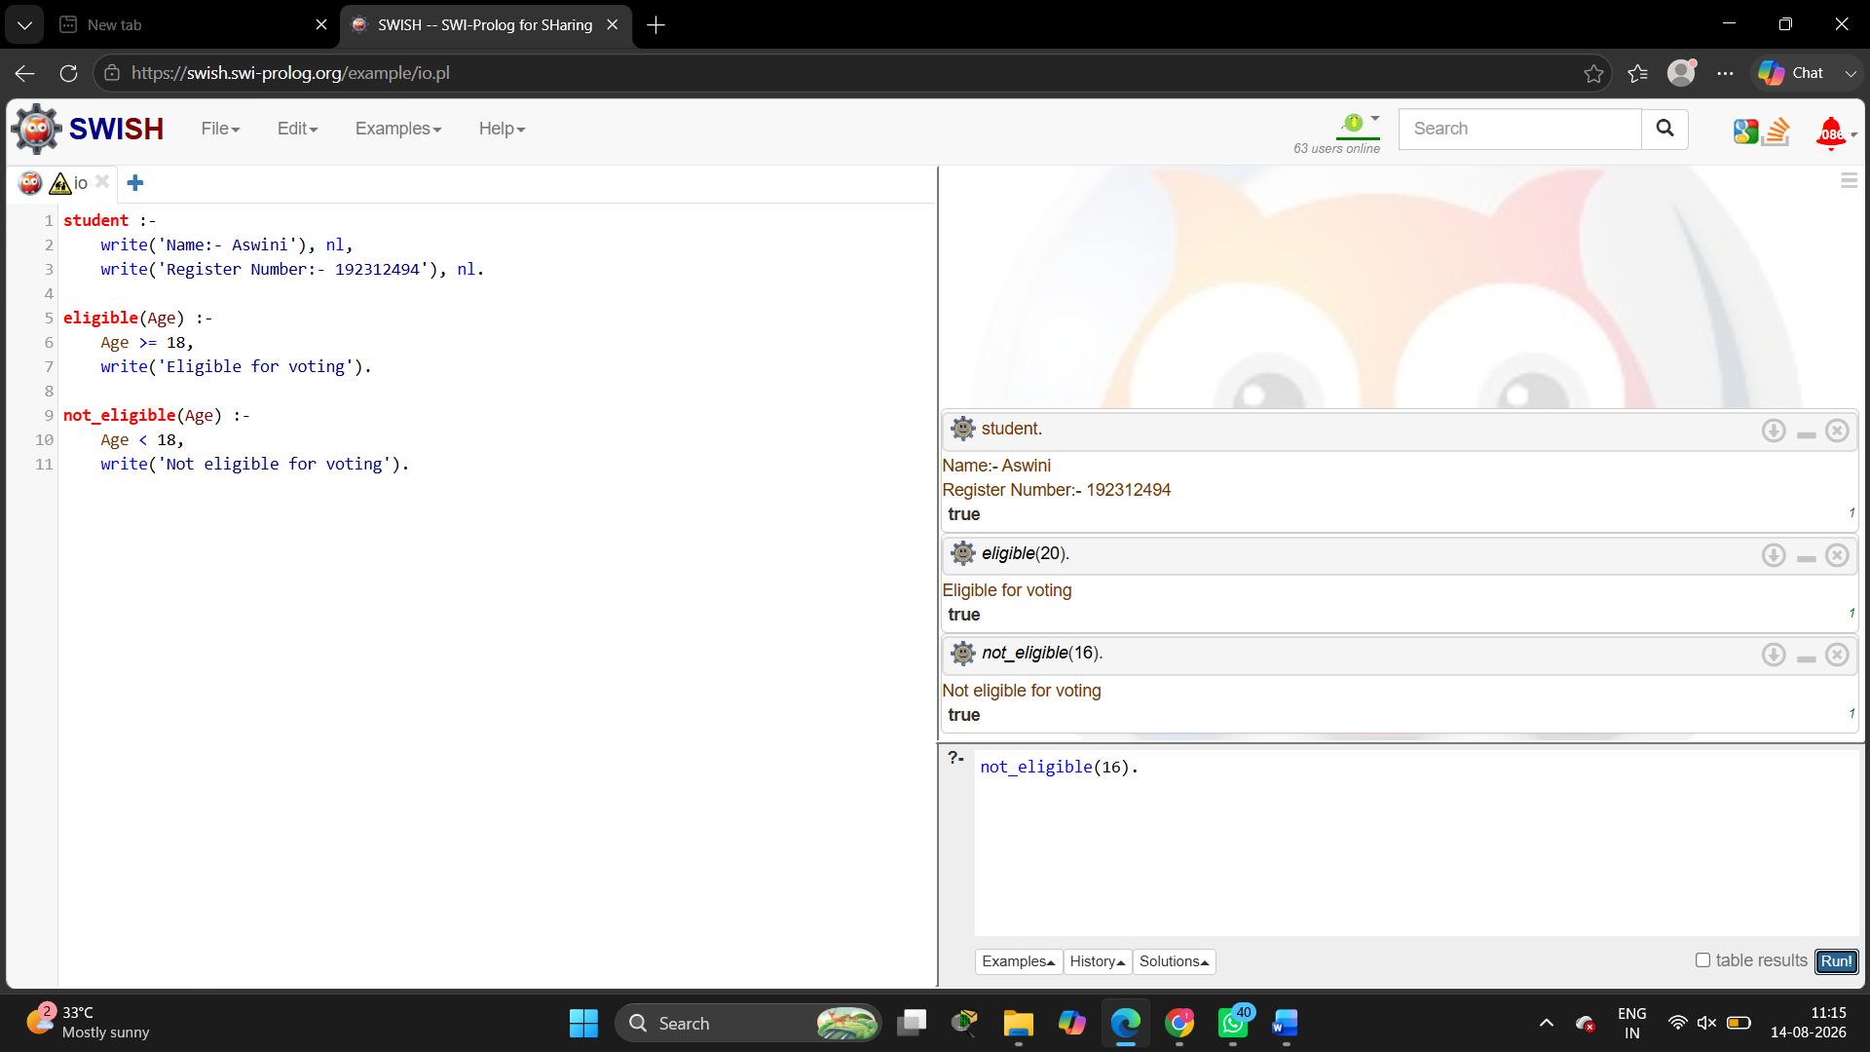

4.celsius_to_fahrenheit
Code:
student :-
write('Name:- Aswini'), nl,
write('Register Number:- 192312494'), nl.

convert(C,F) :-
F is (C * 9/5) + 32.
Output:
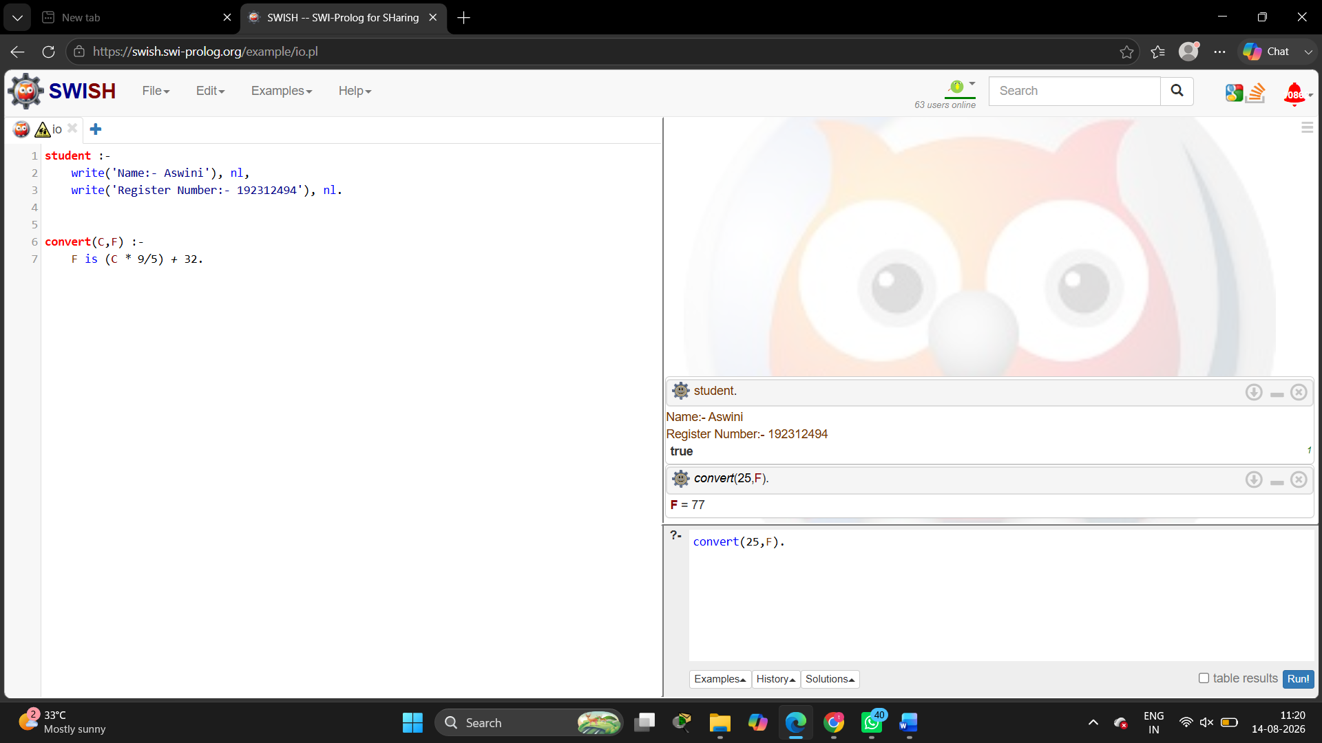

5.Pass/Fail 3 sub
Code:
student :-
write('Name:- Aswini'), nl,
write('Register Number:- 192312494'), nl.

result(M1,M2,M3) :-
(M1 >= 40, M2 >= 40, M3 >= 40 ->
write('Pass')
;
write('Fail')
).
Output:
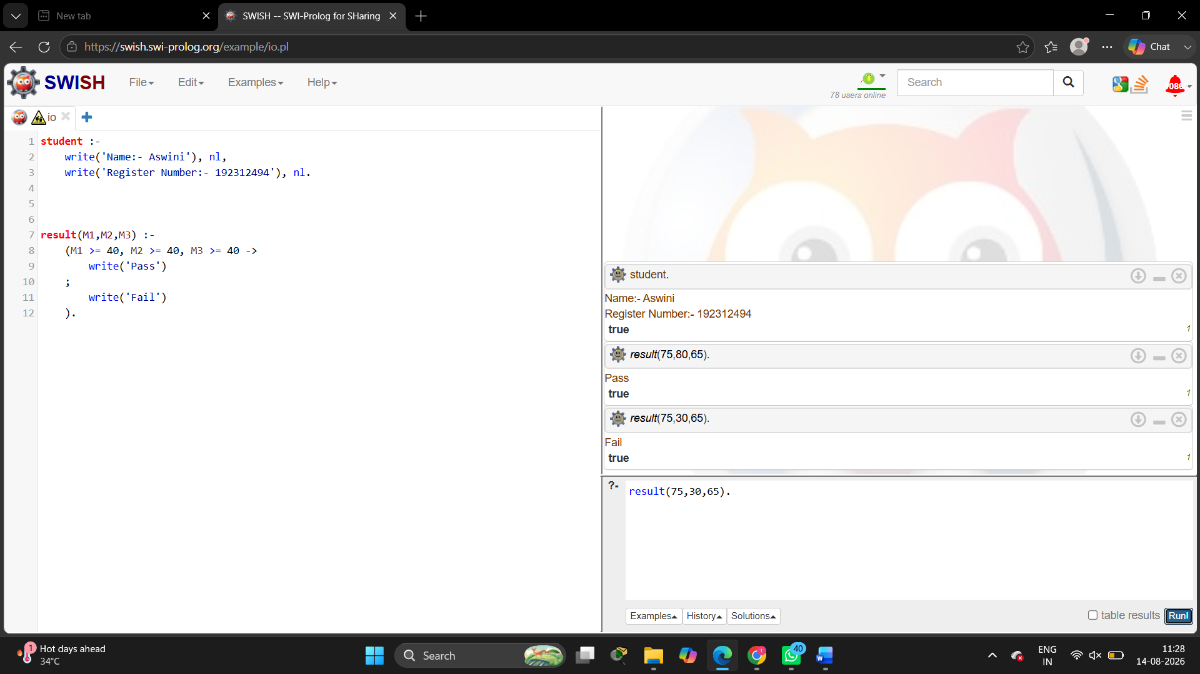

6.Avg of 5 numbers
Code:
student :-
write('Name:- Aswini'), nl,
write('Register Number:- 192312494'), nl.

average(A,B,C,D,E,Avg) :-
Avg is (A+B+C+D+E)/5.
Output:
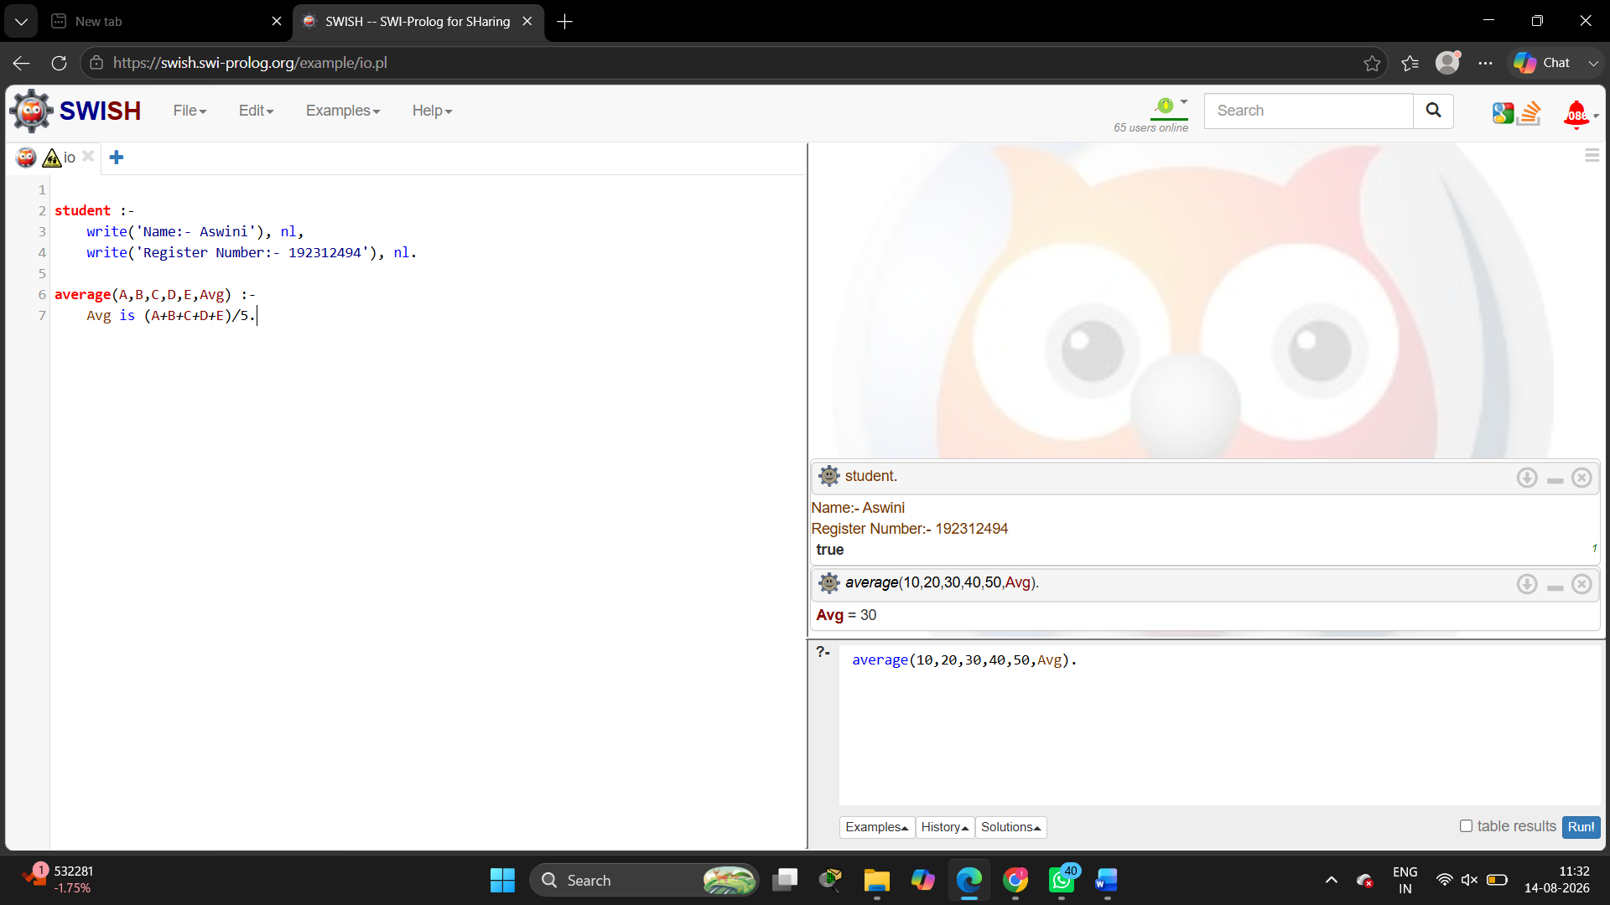

7.Multiplication Table
Code:
student :-
write('Name:- Aswini'), nl,
write('Register Number:- 192312494'), nl.

table(N) :-
table(N, 1).

table(_, 11) :- !.

table(N, I) :-
R is N * I,
write(N), write(' x '), write(I),
write(' = '), write(R), nl,
I1 is I + 1,
table(N, I1).
Output:
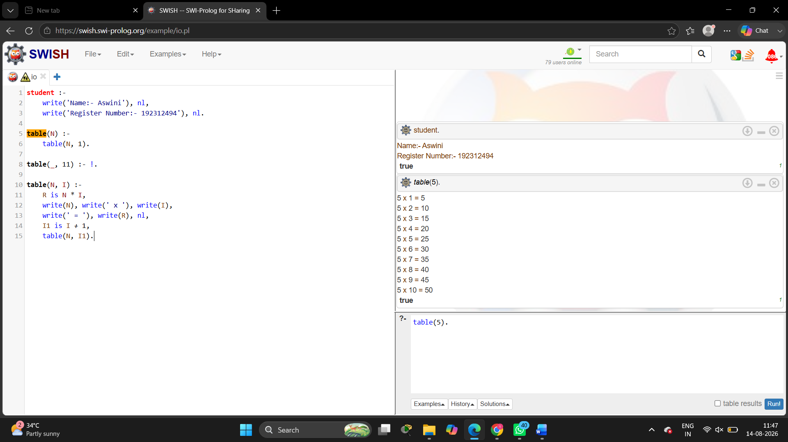

8.Student teacher subject relation
Code:
student :-
write('Name:- Aswini'), nl,
write('Register Number:- 192312494'), nl.

teacher(teaches, maths, ravi).
teacher(teaches, science, priya).
teacher(teaches, english, kumar).

student_subject(aswini, maths).
student_subject(aswini, science).
student_subject(aswini, english).

relation(Student, Subject, Teacher) :-
student_subject(Student, Subject),
teacher(teaches, Subject, Teacher).
Output:
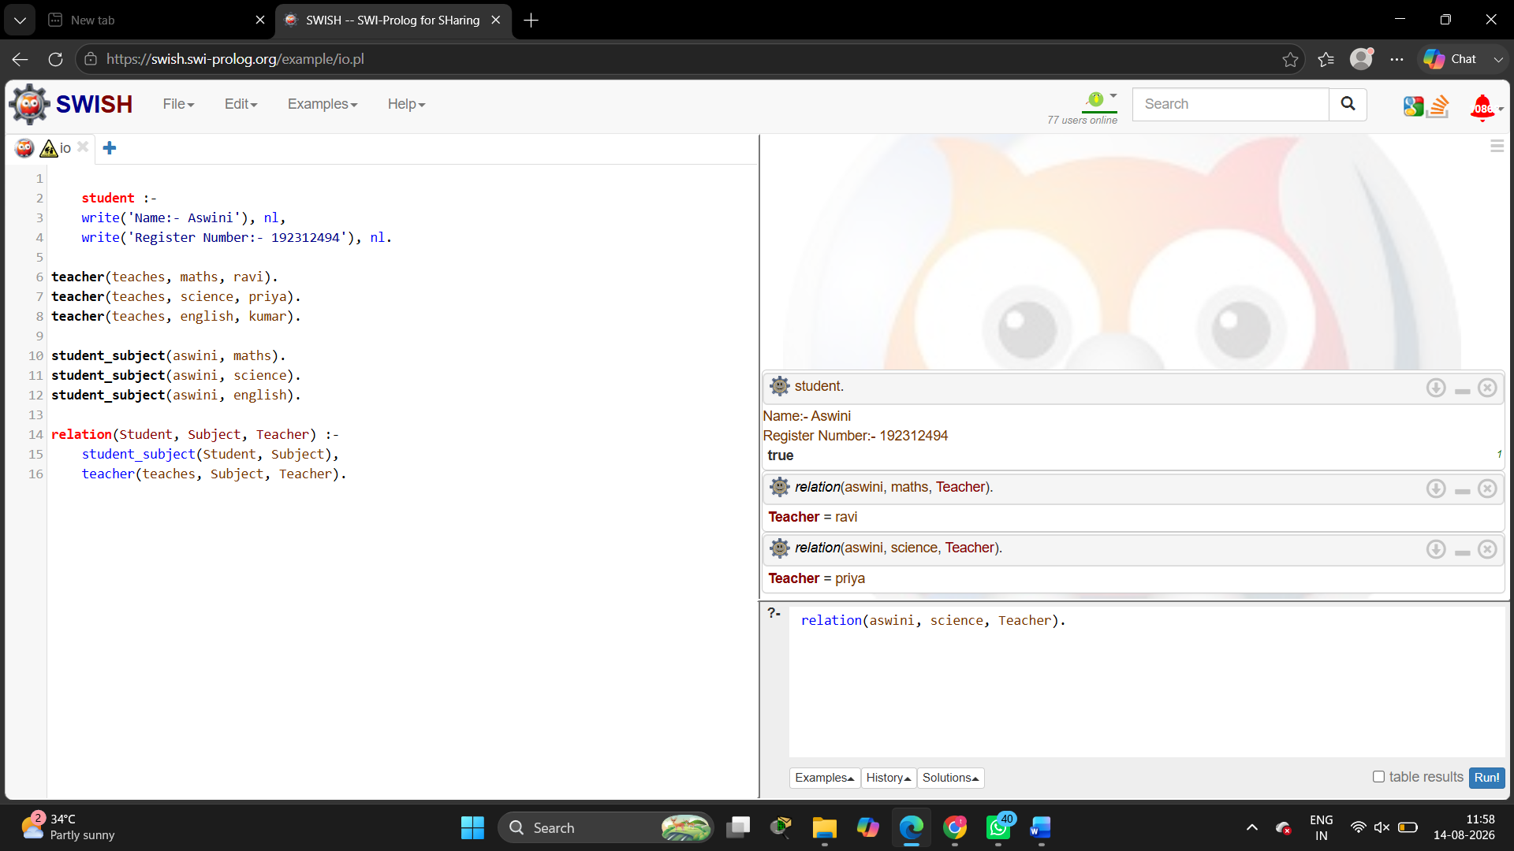

9.Family tree – all realtion
Code:
student :-
write('Name:- Aswini'), nl,
write('Register Number:- 192312494'), nl.

parent(ravi, aswini).
parent(priya, aswini).
parent(kumar, ravi).
parent(latha, ravi).

father(X,Y) :-
parent(X,Y),
X = ravi.

mother(X,Y) :-
parent(X,Y),
X = priya.

child(X,Y) :-
parent(Y,X).

grandparent(X,Y) :-
parent(X,Z),
parent(Z,Y).

sibling(X,Y) :-
parent(P,X),
parent(P,Y),
X \= Y.
Output:
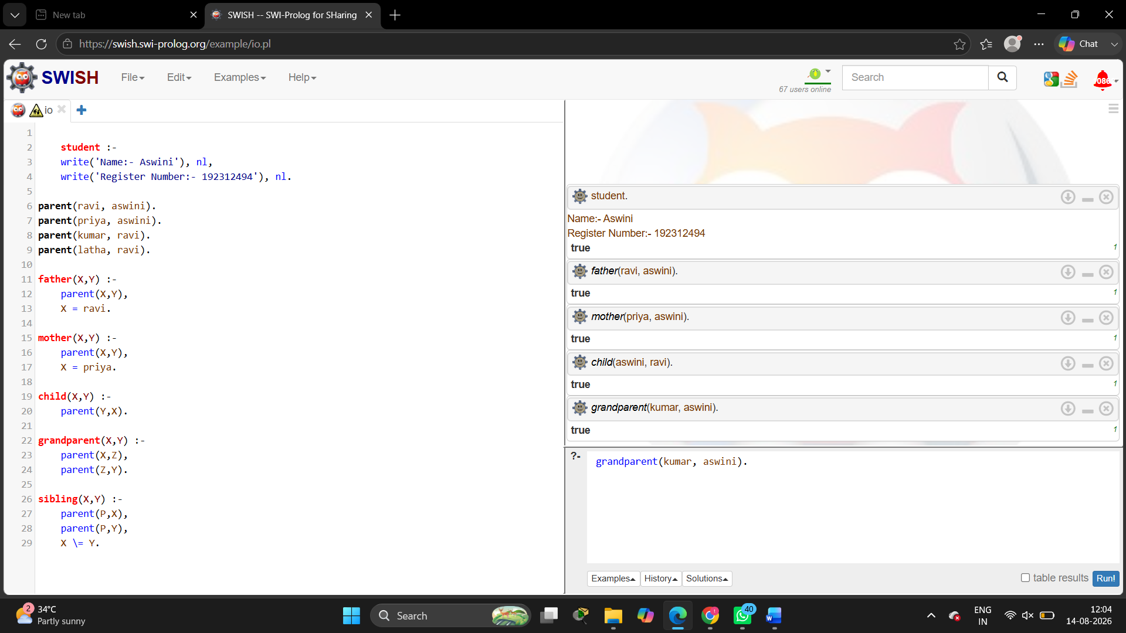

10.Dieting system based disease
Code:
student :-
write('Name:- Aswini'), nl,
write('Register Number:- 192312494'), nl.

diet(diabetes, 'Low sugar diet').
diet(obesity, 'Low calorie diet').
diet(anemia, 'Iron rich diet').
diet(blood_pressure, 'Low salt diet').
Output:

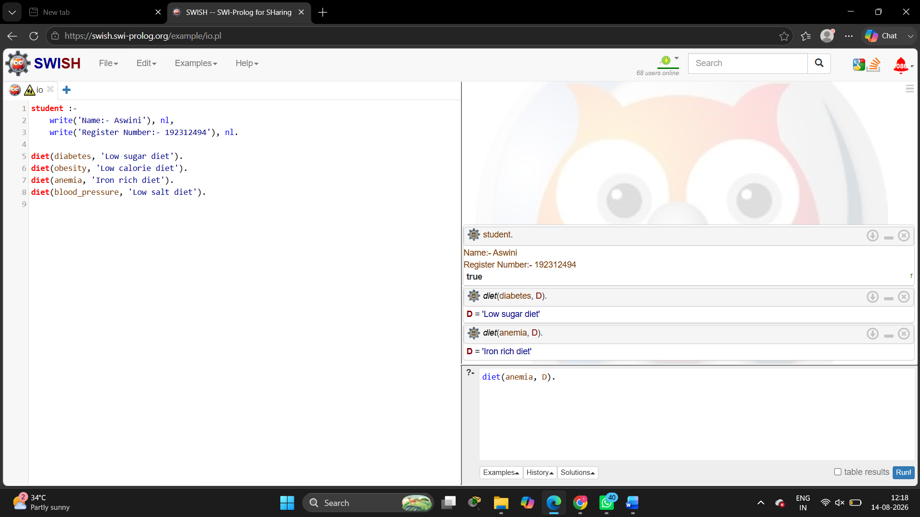

11.Forward / backward chaining
Code:
student :-
write('Name:- Aswini'), nl,
write('Register Number:- 192312494'), nl.

bird(parrot).
bird(crow).

fly(X) :-
bird(X).
Output:
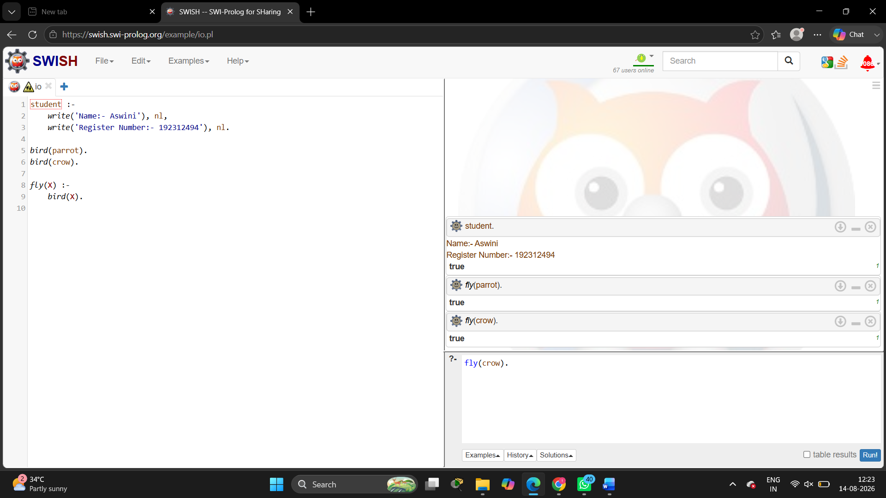

12. Monkey banana problem
Code:
student :-
write('Name:- Aswini'), nl,
write('Register Number:- 192312494'), nl.

monkey(at_door).
banana(on_table).

can_get_banana :-
monkey(at_door),
banana(on_table),
write('Monkey moves to table and gets banana').
Output:
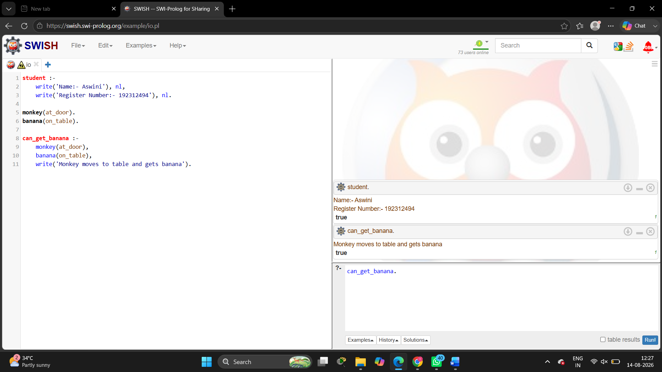

13. Fruit and color – backtracking
Code:
student :-
write('Name:- Aswini'), nl,
write('Register Number:- 192312494'), nl.

fruit(apple, red).
fruit(banana, yellow).
fruit(grapes, green).
fruit(orange, orange).

Output:

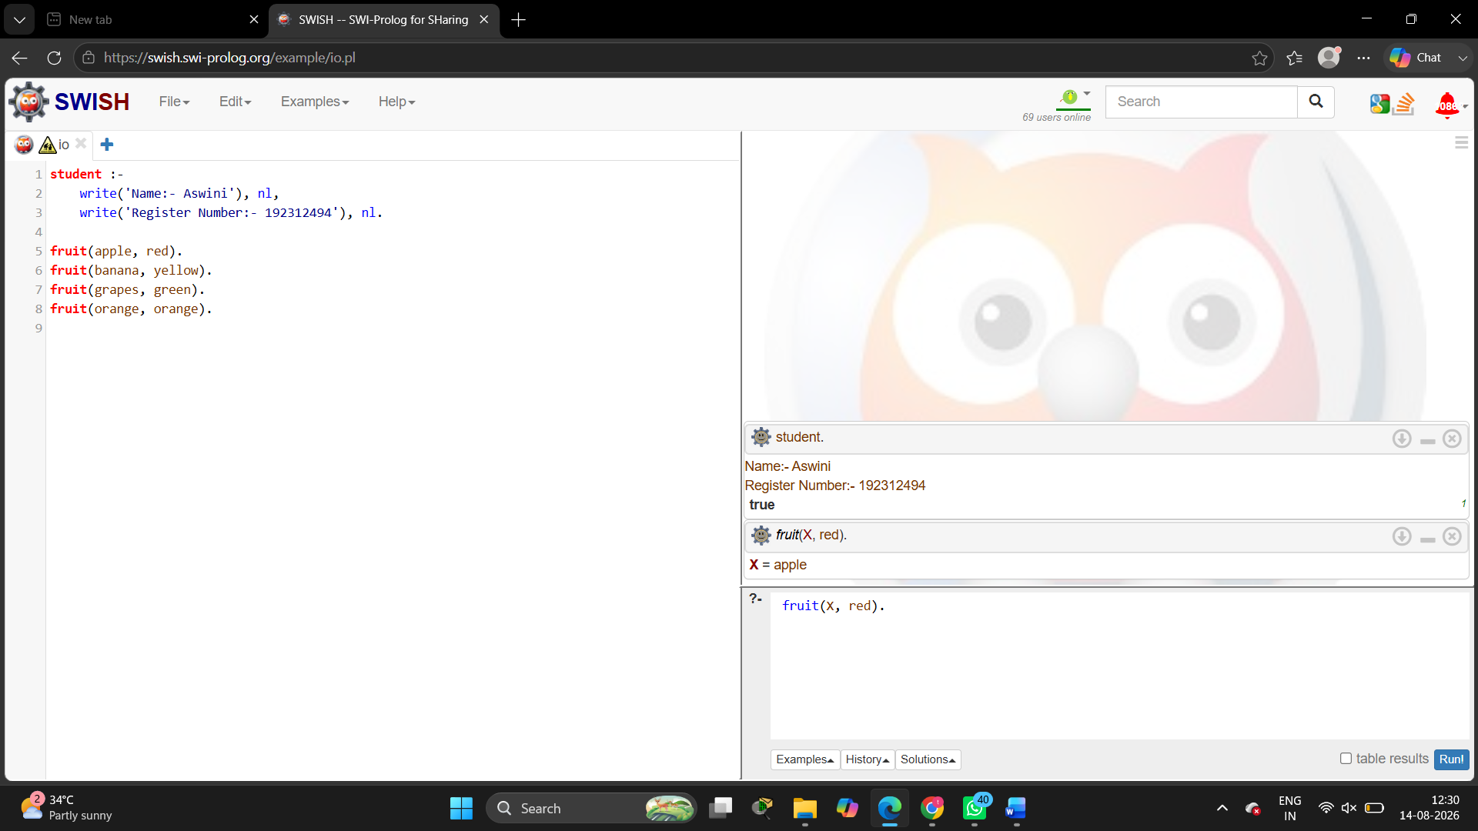

14. Bird fly or not
Code:
student :-
write('Name:- Aswini'), nl,
write('Register Number:- 192312494'), nl.

bird(parrot).
bird(crow).
bird(penguin).

can_fly(parrot).
can_fly(crow).

cannot_fly(penguin).
Output:
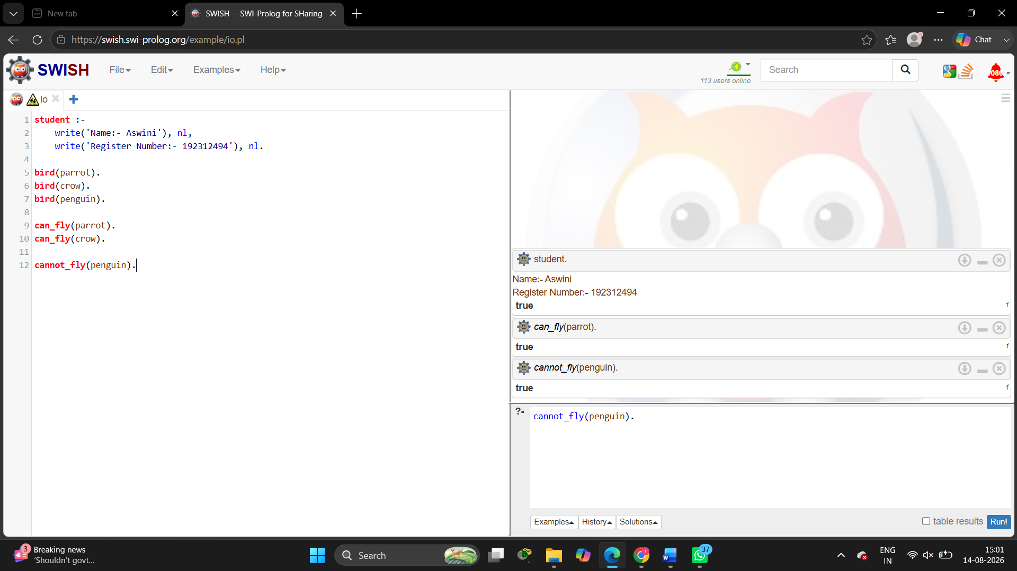

15. Grade find
Code:
student :-
write('Name:- Aswini'), nl,
write('Register Number:- 192312494'), nl.

grade(Mark, 'A') :-
Mark >= 90, !.

grade(Mark, 'B') :-
Mark >= 75,
Mark < 90, !.

grade(Mark, 'C') :-
Mark >= 60,
Mark < 75, !.

grade(Mark, 'D') :-
Mark >= 40,
Mark < 60, !.

grade(Mark, 'F') :-
Mark < 40.
Output:
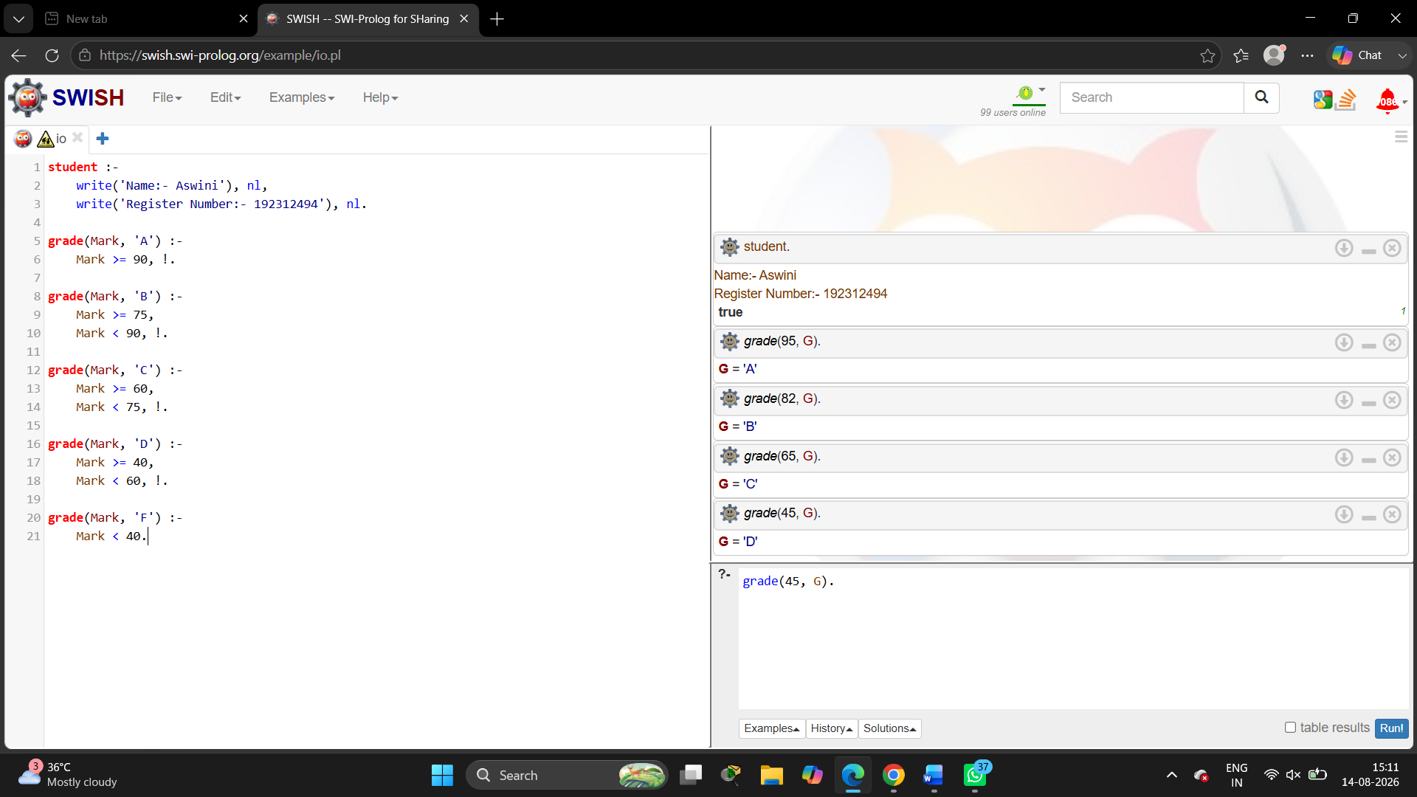

16. EB bill Program
Code:
student :-
write('Name:- Aswini'), nl,
write('Register Number:- 192312494').

bill(U, B) :-
U =< 100, B is 0, !.
bill(U, B) :-
U =< 200, B is (U-100)*2.25, !.
bill(U, B) :-
U =< 500, B is 225+(U-200)*4.5, !.
bill(U, B) :-
B is 1575+(U-500)*6.
Output:
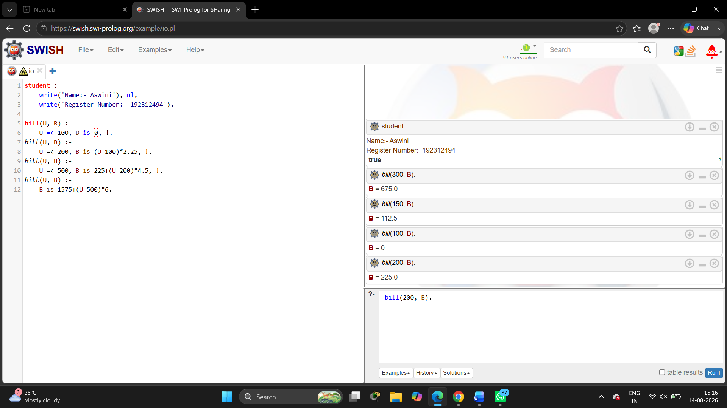

17. Student database
Code:
student :-
write('Name:- Aswini'), nl,
write('Register Number:- 192312494'), nl.

student_data(101, aswini, ece, 90).
student_data(102, ravi, ece, 85).
student_data(103, priya, cse, 95).
student_data(104, arun, eee, 80).
Output:
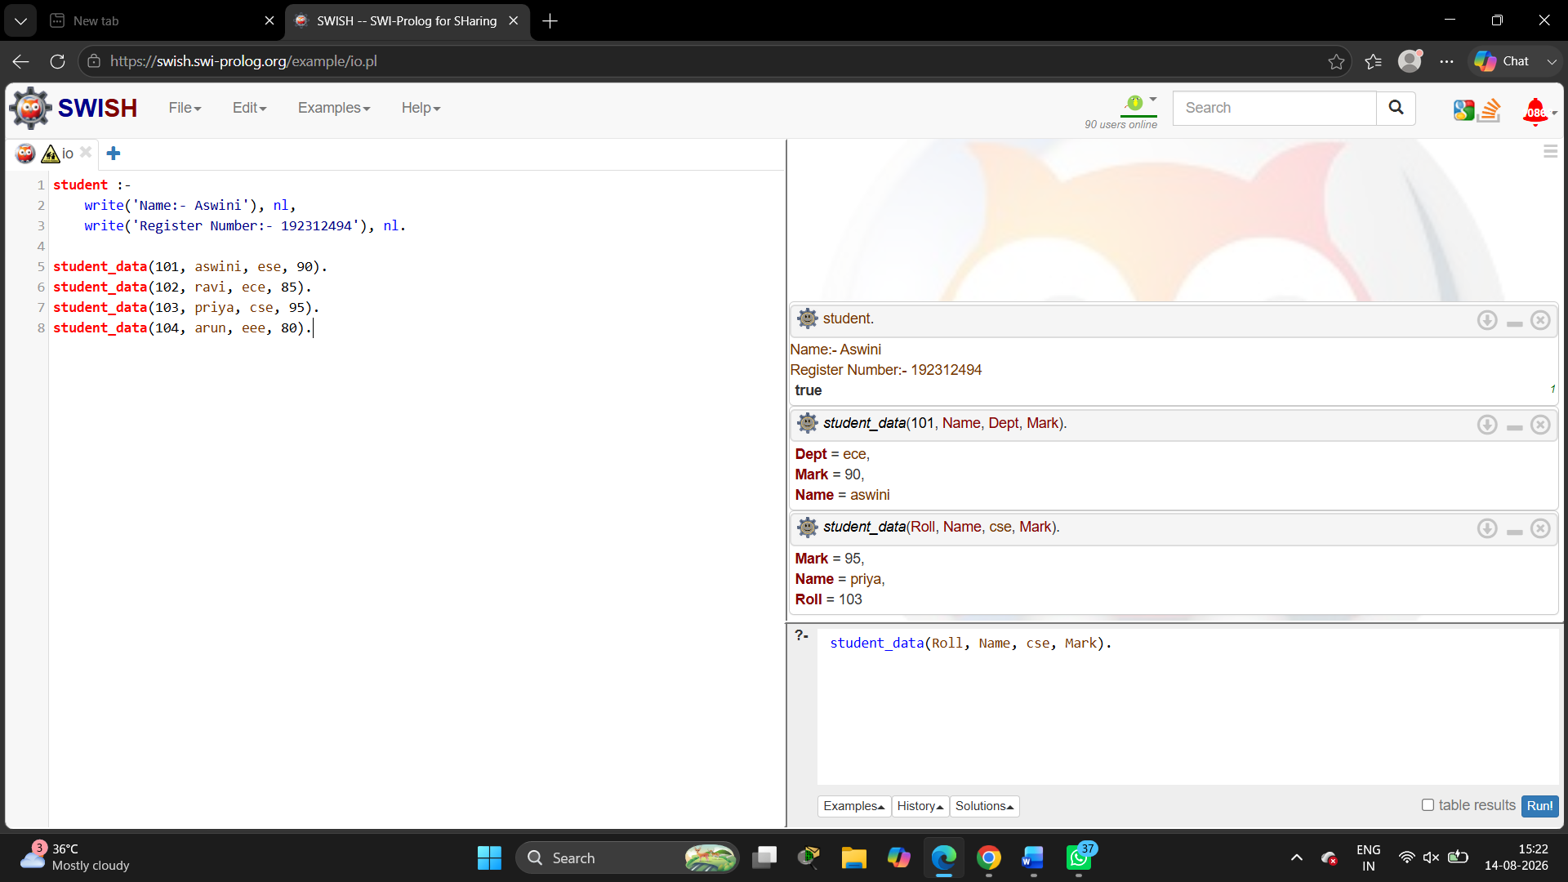

18. Print 1 to 10
Code:
student :-
write('Name:- Aswini'), nl,
write ('Register Number:- 192312494'), nl.

print_numbers(10).

print_numbers(N) :-
N > 10, !.

print_numbers(N) :-
write(N), nl,
N1 is N + 1,
print_numbers(N1).
Output:
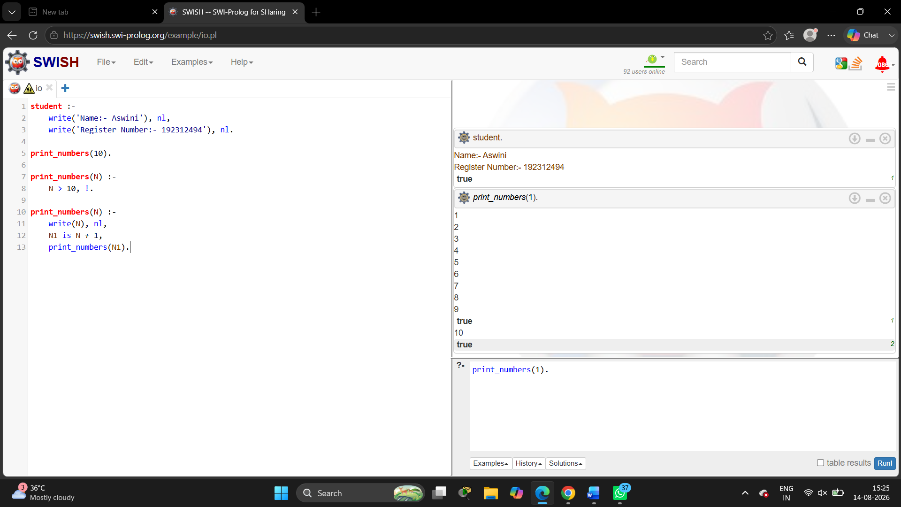

19. N queens Problem
Code:
student :-
write('Name:- Aswini'), nl,
write('Register Number:- 192312494'), nl.

queens(S) :-
permutation([1,2,3,4], S),
safe(S).

safe([]).

safe([X|Xs]) :-
safe(Xs),
check(X, Xs, 1).

check(_, [], _).

check(X, [Y|Ys], D) :-
X =\= Y,
X-Y =\= D,
Y-X =\= D,
D1 is D+1,
check(X, Ys, D1).
Output:
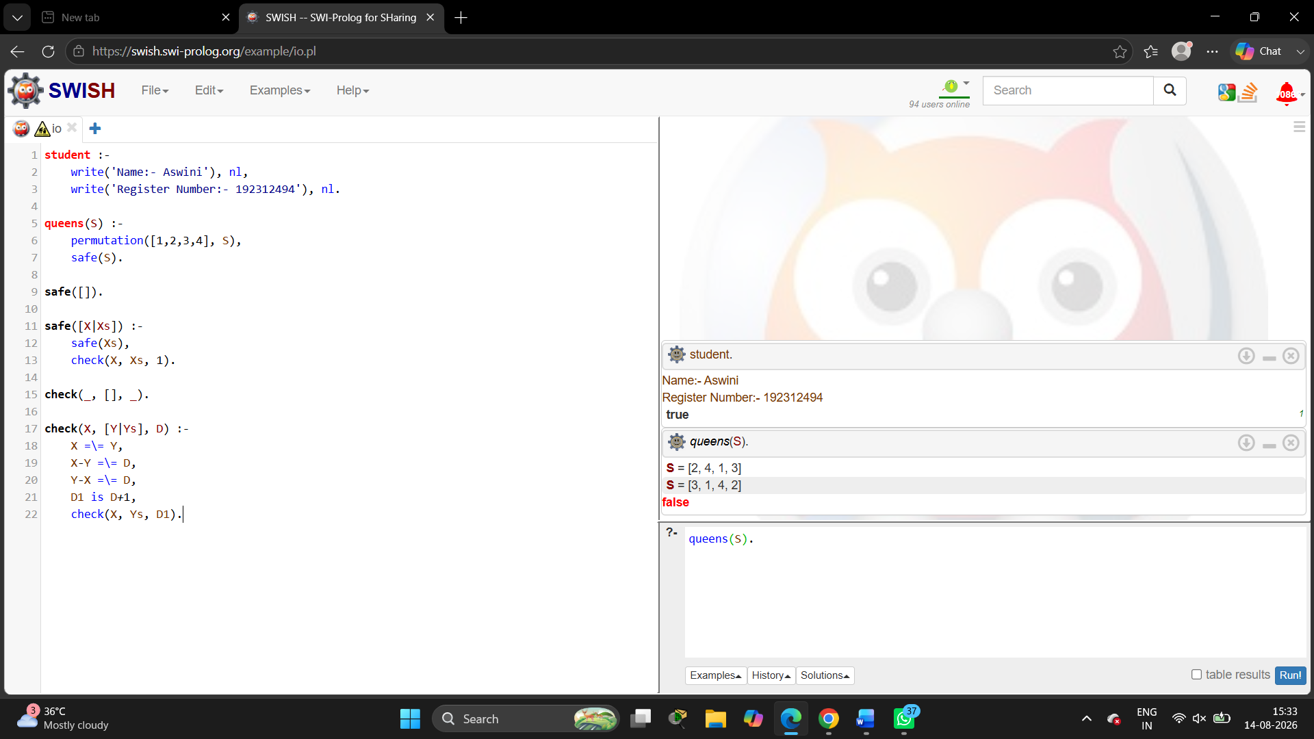
20. Reverse a number
Code:
student :-
write('Name:- Aswini'), nl,
write('Register Number:- 192312494'), nl.

reverse_num(N, R) :-
reverse_num(N, 0, R).

reverse_num(0, R, R).
reverse_num(N, A, R) :-
D is N mod 10,
N1 is N // 10,
A1 is A * 10 + D,
reverse_num(N1, A1, R).
Output:
